[This Photo](http://commons.wikimedia.org/wiki/File:Brookfield_Asset_Management_logo.svg) by Unknown Author is licensed under [CC BY-SA](https://creativecommons.org/licenses/by-sa/3.0/)



08/20/2024

SCCM Dashboard-POWER BI

SArah Mohammad ABdul Rasheed

Student, Data Analytics & Integration

BSG IT, Business Services Group

Brookfield Renewable

# Dashboard pages

1.All Intune devices registered in Azure Cloud.

2.All managed and detected apps installed on those devices.

3. Windows Patching on the devices along with the edition, revision and known issues.

# Data Sources**:**

# **1.Graph API Calls**

STEP 1:

STEP 2: Step 1: For Graph Api Calls: Go To New Source->Blank Query->Advanced Editor

STEP 3:

a) For Devices: <https://graph.microsoft.com/beta/user>

[License assignment, Onpremise Extension attribute-represents Business Group]

b) Managers: <https://graph.microsoft.com/beta/users?$select=id,manager>

Managers Display Name and Email are added as columns through Lookup Value

b) For Managed Devices: https://graph.microsoft.com/v1.0/deviceManagement/managedDevices

d)For Mobile (Managed)Apps: https://graph.microsoft.com/v1.0/deviceAppManagement/mobileApps, <https://graph.microsoft.com/v1.0/deviceAppManagement/managedAppRegistrations>

e) For Detected Apps: Through power Automate:detected_apps_flow:

Define folder path where report is downloaded 

f) For Windows Feature Updates(Patch Tuesday): <https://graph.microsoft.com/beta/admin/windows/updates/products>

# **2. From intune Data Warehouse**

**OData Feed for Intune Reporting:** https://fef.msua05.manage.microsoft.com/ReportingService/DataWarehouseFEService?api-version=v1.0

# Dashboard pages

**DEVICES**

**Mobile Apps/Managed Apps**

**Detected Apps**

**Patching:**

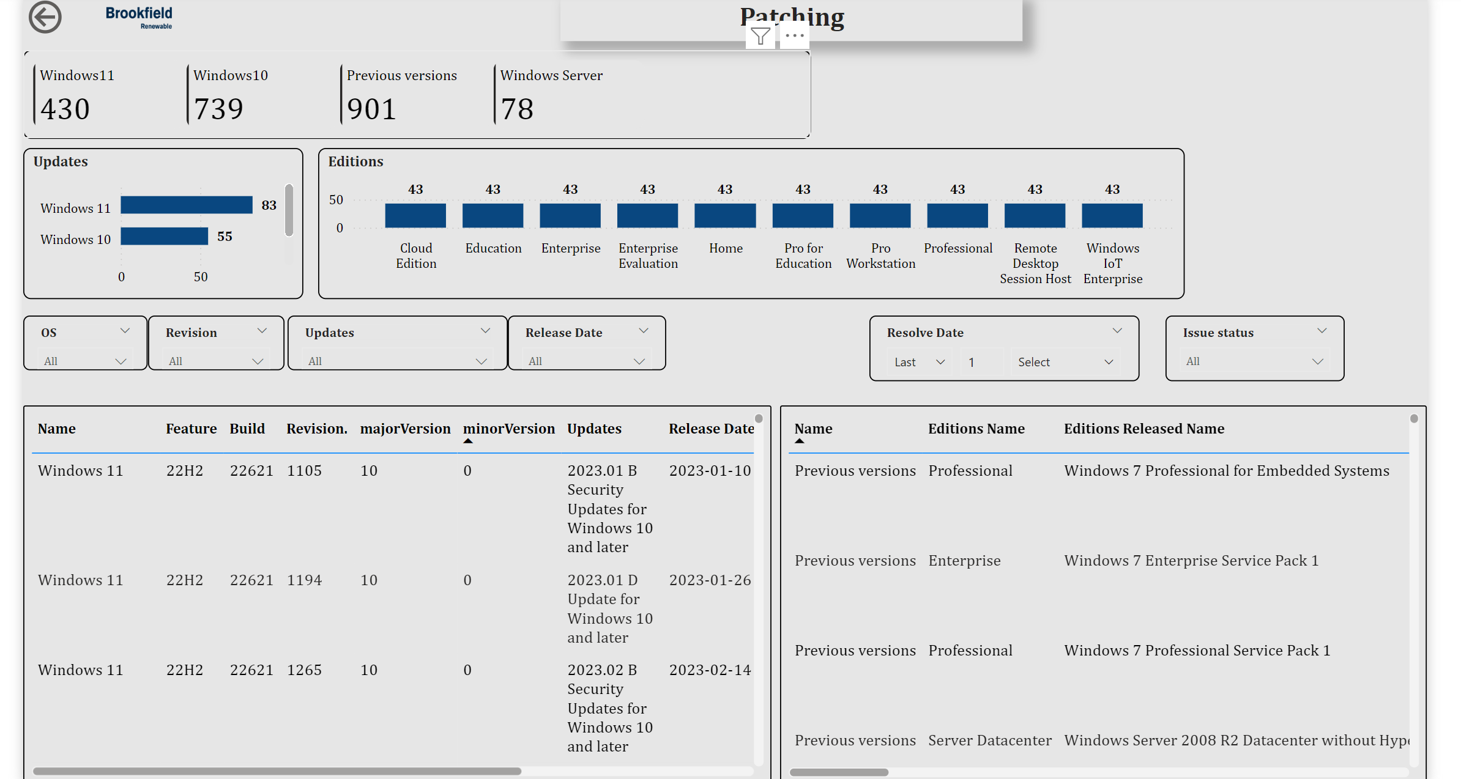

*Issues* :Patching Report Not connected with the devices

*

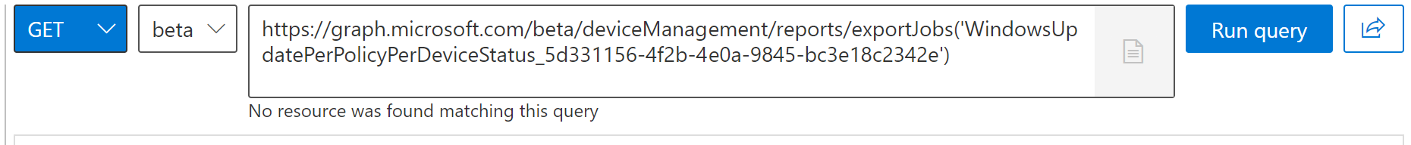

Resources:

[Anatomy of a Microsoft Graph connector](https://devblogs.microsoft.com/microsoft365dev/anatomy-of-a-microsoft-graph-connector/)

[Intune Graph API - Reports and properties | Microsoft Learn](https://learn.microsoft.com/en-us/mem/intune/fundamentals/reports-export-graph-available-reports)

[Update release cycle for Windows clients | Microsoft Learn](https://learn.microsoft.com/en-us/windows/deployment/update/release-cycle#monthly-security-update-release)

[adminWindowsUpdates resource type - Microsoft Graph beta | Microsoft Learn](https://learn.microsoft.com/en-us/graph/api/resources/adminwindowsupdates?view=graph-rest-beta&preserve-view=true)

[Get Microsoft Graph Activity Logs Using Azure Portal (m365scripts.com)](https://m365scripts.com/microsoft365/get-microsoft-graph-activity-logs-using-azure-portal/)

[Create an Azure automation runbook | smsagent.blog](https://docs.smsagent.blog/microsoft-endpoint-manager-reporting/automating-data-exports-from-microsoft-graph/azure-automation-account/create-an-azure-automation-runbook)

[Create custom Intune reports with Microsoft Graph, Azure Automation and Power BI (smsagent.blog)](https://smsagent.blog/2021/05/12/create-custom-intune-reports-with-microsoft-graph-azure-automation-and-power-bi/)

[The Model PowerBI Dashboard - Model Technology (model-technology.com)](https://model-technology.com/model-powerbi-dashboard/)